“Emergency” will not arise in normal running status unless the unit is in emergency running status.

Slightly press the button “Run Data” to enter the interface of “Data Inquiry”. Slightly press the button “Run Curve” to enter the interface of “Running Curve Inquiry”. Slightly press the button “History Curve” to enter the interface of “History Curve Inquiry”.

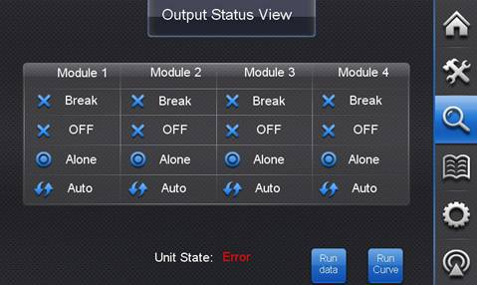

（2）Data Inquriy

The current inquired module, including the on/off status and parameters of each part, is displayed. Press the button of “Switch Module” to switch the data from module 1 to module 4.

On this page, running status and parameters of each key part can be viewed, including the on/off status of indoor fan, compressor 1 and compressor 2, and the pulse of electronic expansion valve. On the interface of “Output Status View”, press **“State”** and then enter the interface of running data inquiry, the pulse of electronic expansion valve is displayed. After entering the homepage, the pulse of EXV will not be displayed.

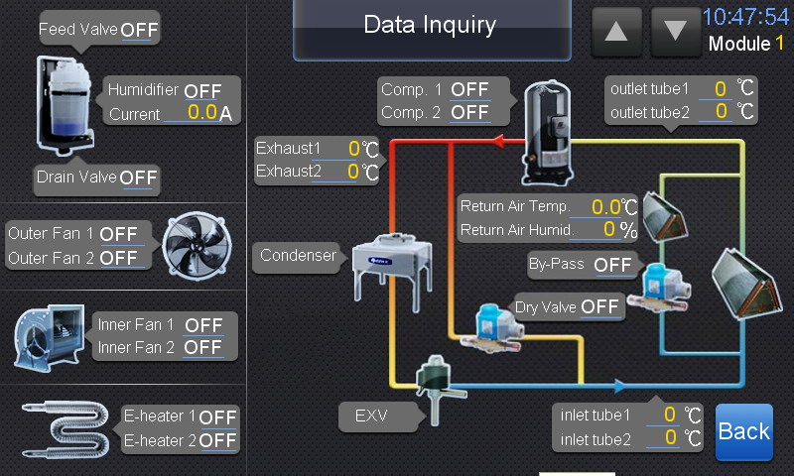

If error exists in the unit, then “Error” will be displayed.

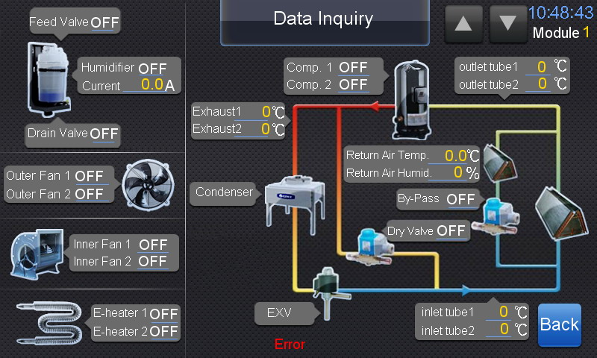

If the module is set as break status, all the corresponding search data is 0.

（3）Running Curve Inquiry

The interface of running curve inquiry displays temperature curve and humidity curve. The horizontal abscissa represents time whereas the vertical ordinate represents temperature or humidity. Red line indicates the return air temperature and the pink line indicates the return air humidity, with the current temperature or humidity value showing at the bottom of the curve diagram. Slightly press module 1, module 2, module 3 or module 4 on top of the curve to switch to the corresponding module.

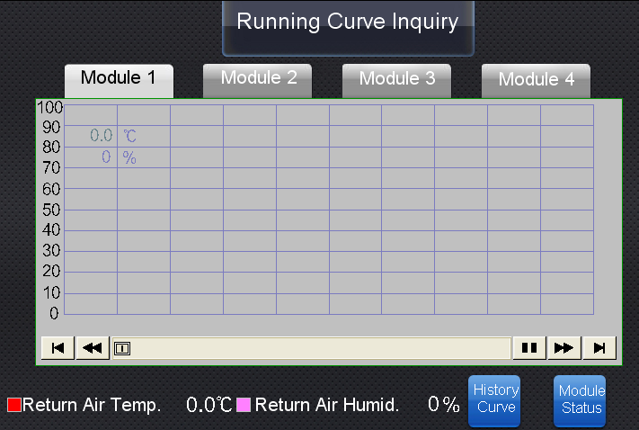

（3）History Curve Inquiry

The button “History Curve” is only displayed on the interface of running curve inquiry. The running curve before unit is last turned off can be viewed. Slightly press module 1, module 2, module 3 or module 4 on top of the curve to switch to the corresponding module.

Press the button “Clear” and then a small window will pop up requiring password input. Input the password correctly and then close it. By this time, press the button “Clear” again. Then a small window will pop up for confirmation. Press “OK” to clear the records of history curve.

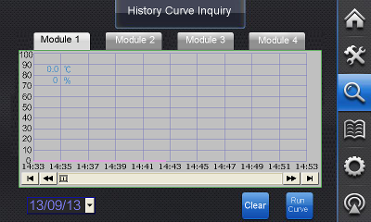

History curve of a certain day can be viewed by selecting the date.

### 2.5 Event Log

（1）Current Error

Slightly press “Event Log” and then the interface of current error will be displayed. This interface shows the current alarms of the unit, which can be viewed one by one by touching the left and right scroll bars.

Press and hold the button “Reset” for 5 seconds, then all the current errors will be reset.

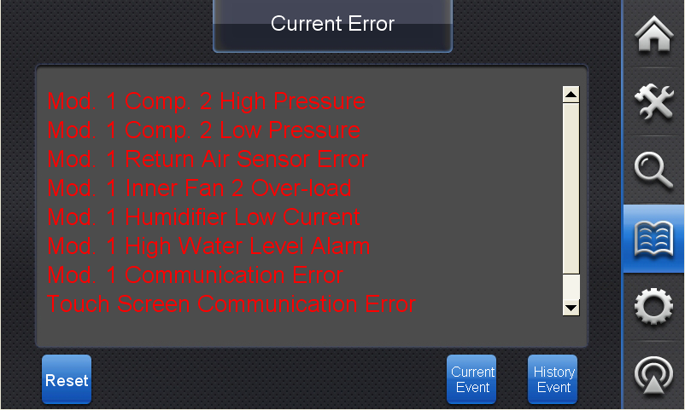

（2）Current Event

Slightly press the button “Current Event” to enter the interface of current event. Then all events happened since unit is turned on this time will be shown. Events can be viewed one by one by slightly touching the left and right scroll bars. System can record 100 current events at most. Red indicates the event is happening. Press the event of error to confirm and the color will change to yellow. When error is recovered, the color will change to green.

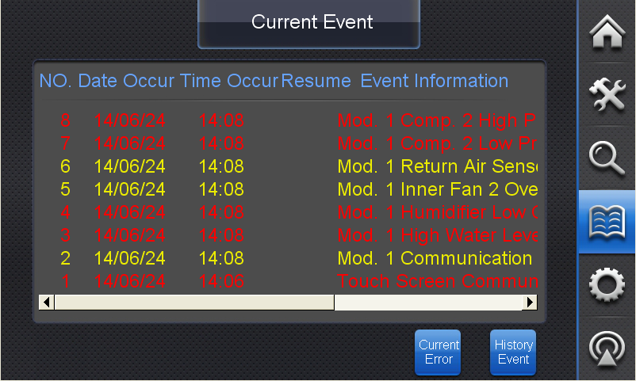

（3）History Event

Slightly press the button “History Event” to enter the interface of history event. All events that occur before the unit is last turned off is displayed and can be viewed by date. Blue indicates that events are happening while green indicates that events are recovered and yellow indicates that events are confirmed.

Slightly press the button “Clear” and a window will pop up requiring password input. If password is correctly input, “Correct Password” will be displayed. Then close the window and press “Clear”. Click “OK” in the pop-up window to clear all the records of “History Event”. History events of a certain day can be viewed by date. Note: When clearing records of “History Event”, “?” will emerge.

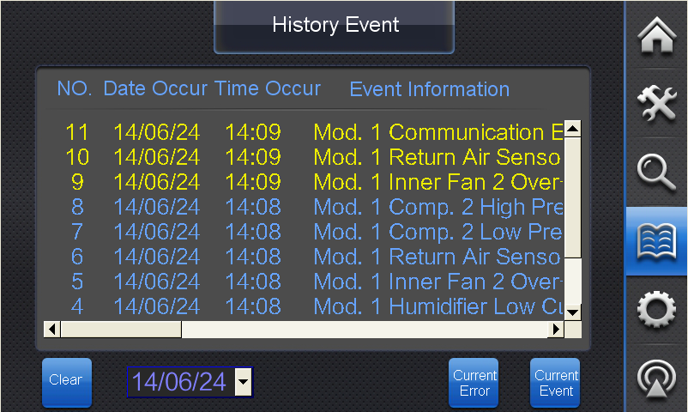

### 2.6 Parameter Setting

Slightly press the button “Parameter Setting” and a window will pop up requiring password input. The access to the interface of parameter setting needs a password. Click the password input box and input: “111111”. Wrong password denies access. Password will be effective until the touch screen is back to homepage. After inputting the correct password, slightly touch the button “Close” and then touch the button “Parameter Setting” to view or operate the interface of “System Parameter Setting”, “Sub-Module Setting”, “Module Service Time”or “Manual Debugging”

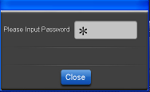

（1）System Parameter Setting

Slightly press the button “Parameter Setting” to set parameters for the system of master module. Slightly touch the value input box to modify the values.

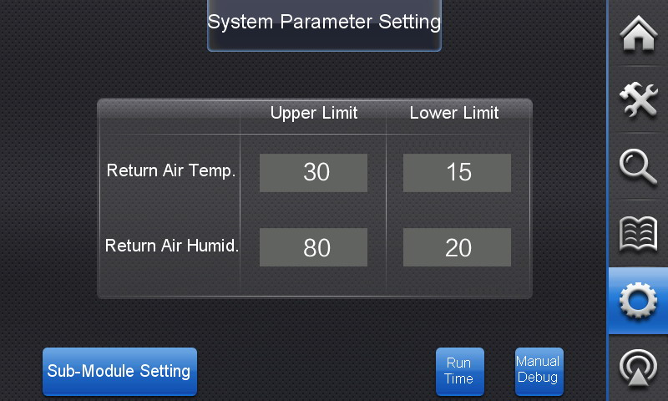

（2）Sub-Module Setting

Slightly press the button “Sub-Module Setting” to adjust parameters for each sub-module, restore default setting or set function shield. Slightly touch “Back” to return to the previous page. Press module 1, module 2, module 3 or module 4 to switch to the corresponding module.

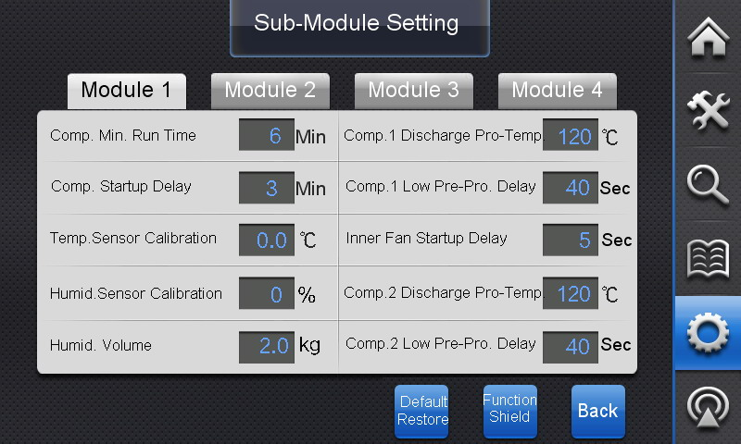

The return air temperature and humidity sensor has been tested before the unit is delivered out of the factory. If any deviation is found during application, it can be corrected according to the following method. Suppose that the temperature and humidity detected by the unit is X℃/Y%, if the corrected value of temperature probe is set to be x℃, the temperature tested by the unit is X+x℃; if the corrected value of humidity probe is set to be y%, the humidity tested by the unit is Y+y%. For example, if the ambient temperature and humidity is 23℃/55%, and the temperature and humidity tested by the unit is 23.2℃/52%, the corrected value of temperature probe shall be -0.2℃ and the corrected value of humidity probe shall be 3%

Slightly press the button “Default Restore” and a window will pop up. Press “Enter” to restore ex-factory setting or press “ESC” to cancel the request.

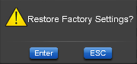

Slightly press the button “Function Shield” to activate shield function against heating, energy saving, humidifying or antistatic. Once the setting is changed, it is enabled. On the pop-up page, slightly press the character “Shield”of “Function Shield” on the top left corner, then the capacity switch code value of each module will be displayed.

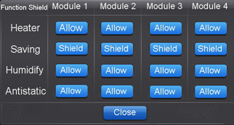

（3）Module Service Time

Slightly press the button “Run Time” to view the accumulated service time of each module and its subsidiary parts. Slightly touch the button “Reset” to clear the service time of the corresponding module or its parts. Note: Clearing the accumated service time will affect module’s operation!

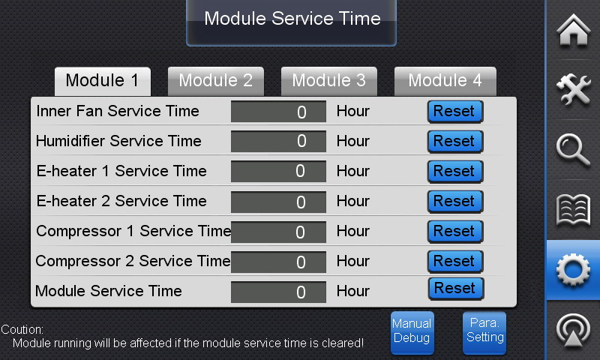

（4）Manual Debugging

Slightly press the button “Manual Debug” to turn on or off the parts of each module.

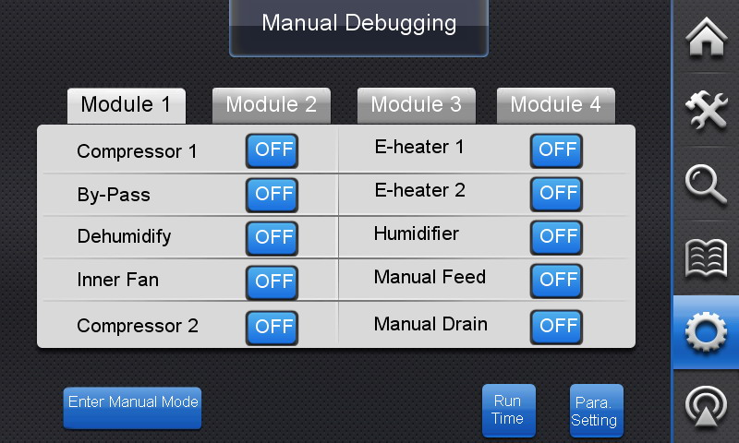

Slightly touch the button “ON/OFF” on the right side of the running part to switch to the manual on/off status of the corresponding part. Words on the button indicate the manual on/off status of the corresponding part.

Under independent auto mode, slightly touch the button “Enter Manual Mode” to enter the manual operation mode. Then each part of the system will run according to the on/off order set for each part. This button will then show words of exit manual mode. Meanwhile, on the interface of “Running Status”, button “Manual/Auto” of the corresponding mode will display “Manua”l. See “4. Running Status Interface” for more details.

Slightly press the button “Exit Manual Mode” to exit the manual operation. Then unit will switch to auto mode and the on/off order set for each part will be invalid.

Note: If units work as a whole, manual debugging is not available.

### 2.7 System Information

（1）System Information

Slightly press the button “System Info” to view “Maintenance Notice”, adjust screen setting, change password or restart the touch screen.

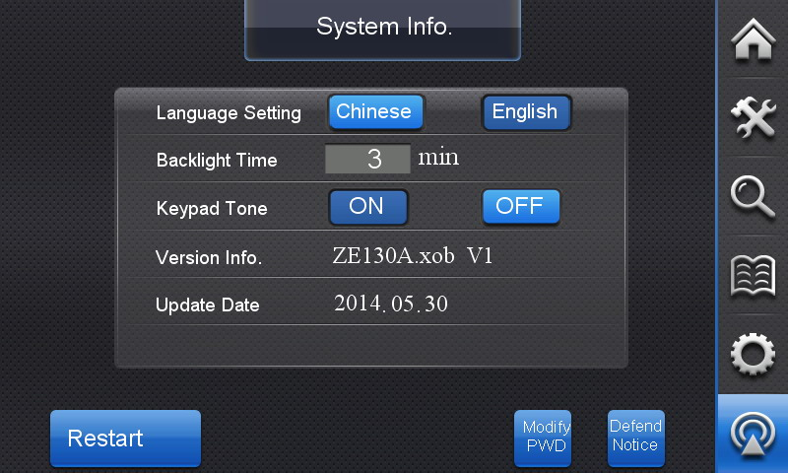

Language of the touch screen can be selected on this page.

Slightly touch the backlight time input box to determine the backlight time of the touch screen.

Slightly press “ON” or “OFF” button to turn on or off the keypad tone.

Touch the button “Restart” slightly for at least 3 seconds, then the touch screen will be restarted. In order to ensure system’s stable operation, please restart the touch screen when units are turned off. This button is immune to shield function.

Note: Restarting the touch screen will clear the temperature and humidity curves.

（2）Change Password

Slightly press the button “Modify PWD” to reset user’s password.

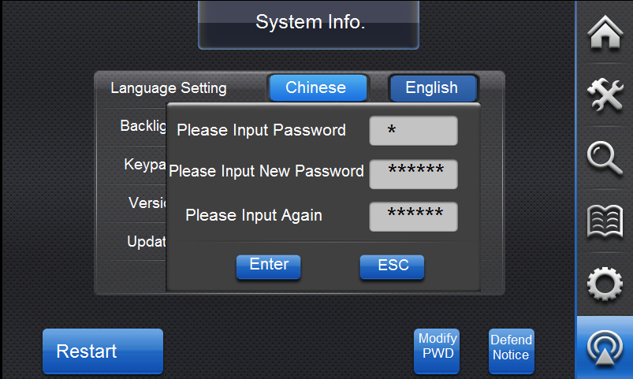

Press “Enter” and if password is valid, it is modified successfully. If not, input password again.

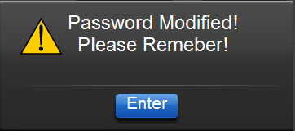 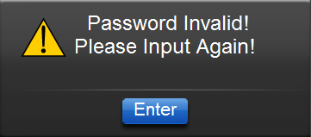

（3）Maintenance Notice

Slightly touch the button “Maintenance Notice” to switch to the page of maintenance notice. User can view information related to maintenance and installation.

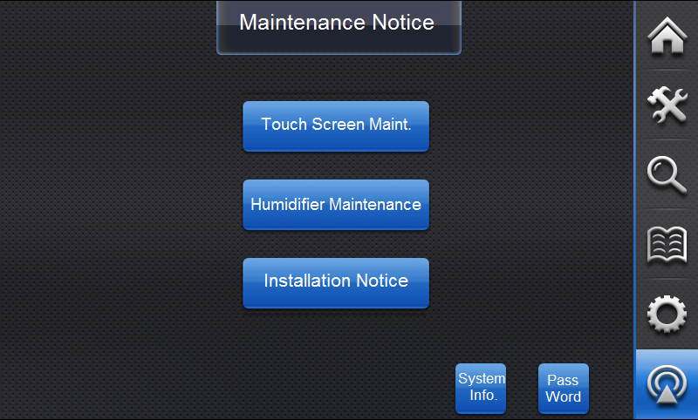

### 2.8Touch Screen Vindicate, Humidifier Maintenance and Installation Notice

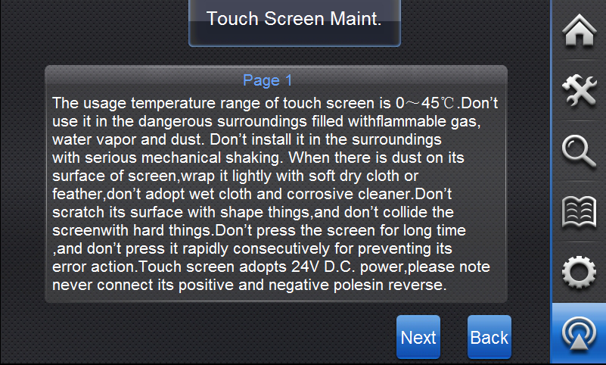

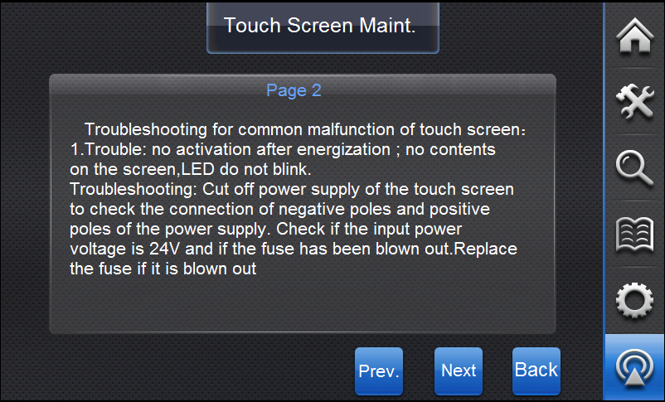

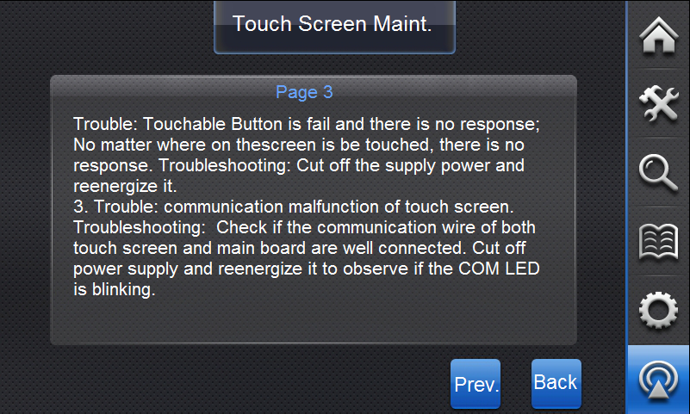

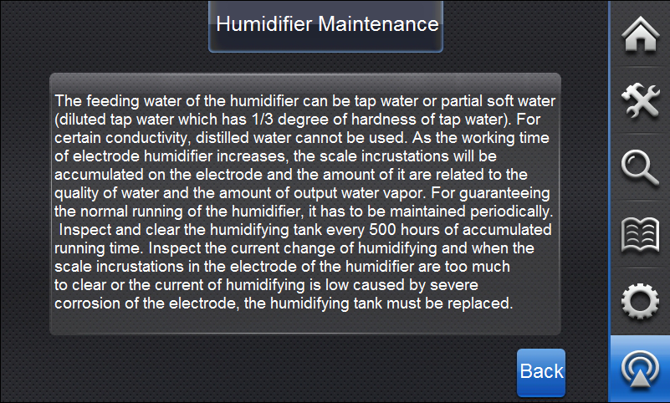

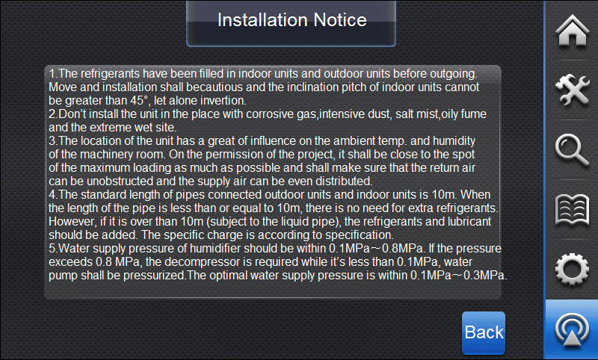

## 3. The Instruction of DIP Switch

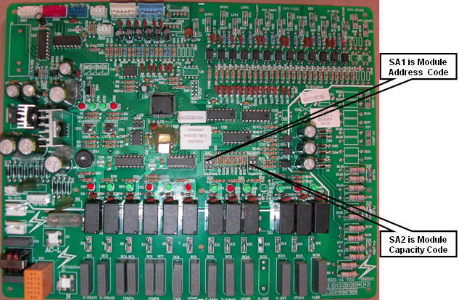

Units Mainboard DIP Switch Diagram

### 3.1 Address Code

Four modules can be combined to run integratedly by 2-bit setting address of DIP switch on SA1 in mainboard of each module. Code is valid before energization and its change is invalid after energization. Coding method is as follows:

|  |  |  |
| --- | --- | --- |
| SA1 Address DIP switch | | Address Code |
| 2 | 1 |
| 0 | 0 | 1# |
| 0 | 1 | 2# |
| 1 | 0 | 3# |
| 1 | 1 | 4# |
| The DIP switch at the position ON represents “0” and at digital terminal represents “1”. | | |

### 3.2 Capacity Code

Capacity code of the unit is the 2-bit DIP switch on SA2 in the mainboard which has been set and fixed by the factory. Users and installation personnel cannot change it.

Note: Address code and Capacity code are valid before energization and the change is invalid after energization.

## 4. Remote Monitoring

Combined parameter characteristic of Air Conditioner and adopted MODBUS communication protocol, this software is designed to provide simple operation interface to view the running status of every unit in real time and set related parameter in long distance with monitoring PC.

警告标识

Note: the remote monitoring accessories are not contained in the standard product; the user should select the accessories according to the requirement.

### 4.1 Installation

#### 4.1.1 System requirements for Gree AC Eudemon 2009

※ Internet Requirements：Microsoft Internet Explorer 6.0 SP1 or later (prerequisite for .NET Framework)

※ RAM：Minimum： 1 GB. Recommended: 2 GB or higher.

※ Hard Disk space： 10 GB free space

※ Processor：Core 2 or higher Minimum: 1 GHz Recommended:2 GHz or higher

※ Operating System ：Windows Server 2003 SP2

Windows Server 2003 Enterprise Edition SP2

Windows XP Professional SP2

Windows Vista Business

Windows Vista Enterprise

Windows Vista Ultimate

Windows 7

#### 4.1.2 Installation, operation and uninstall

● **Install**

If you are installing Gree AC Eudemon 2009, you must run Setup as an administrator, put the CD in CD-ROM, run the autorun.exe.

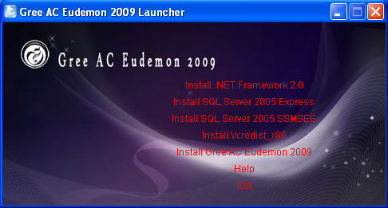

Perform the folling steps in order:

1. Install Microsoft SQL Server 2005 Express Edition

2. Install Microsoft SQL Server 2005 SSMSEE

3. Install Vcredist_x86

4. Install Gree AC Eudemon 2009

Click “help” for installation flow.

● **Run**

Click “start→program→GREE→ Gree AC Eudemon 2009” or double-click  on desktop to start this software, the interface is as following:

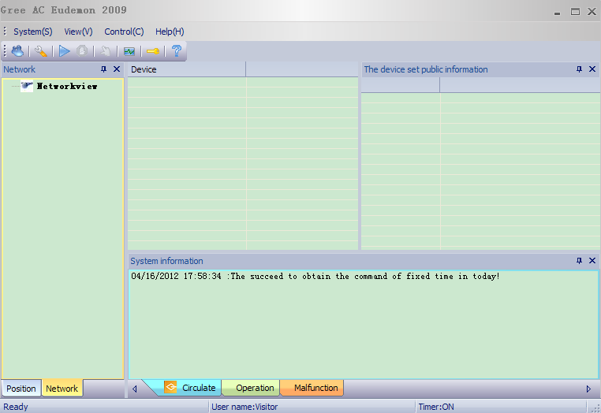

● **Uninstall**

Double-click the system icon in Control Panel to uninstall this program.

Click  from “start→program→GREE→Gree AC Eudemon 2009” to uninstall the program.

### 4.2 Operation

#### 4.2.1 Login Window

Run Gree AC Eudemon 2009.exe as an administrator in the installation catalogue. (The shortcut of "AC Eudemon 2009" can be found in Menu Bar or desktop)

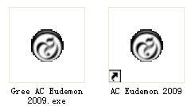

The pop-up interface of the software will be as below:

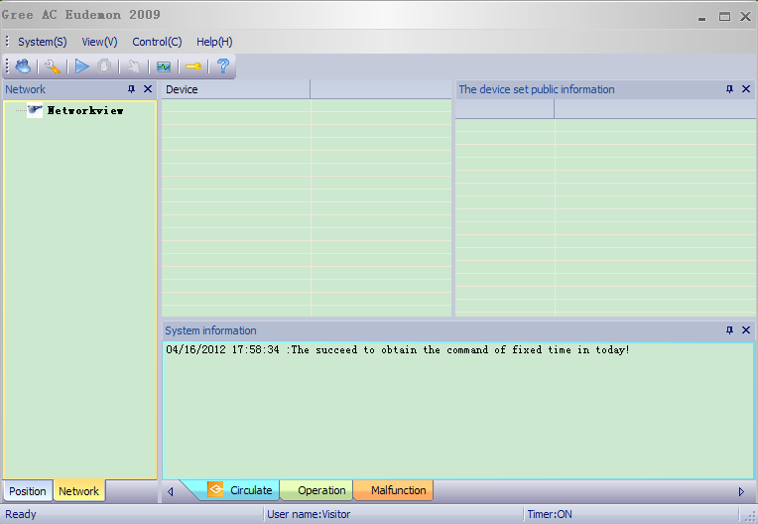

Click Main Menu->System ->The customer login. Then input user name(admin) and password(null) and click Login.

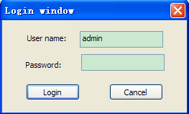

#### 4.2.2 The Engineering Install

Click Main Menu->System->The engineering install, and then fill in the engineering information. Click "OK" to finish the configuration.

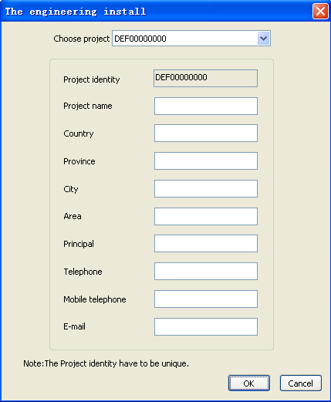

#### 4.2.3 System Configuration

Click Main Menu->System->The system install and the following interface will show.

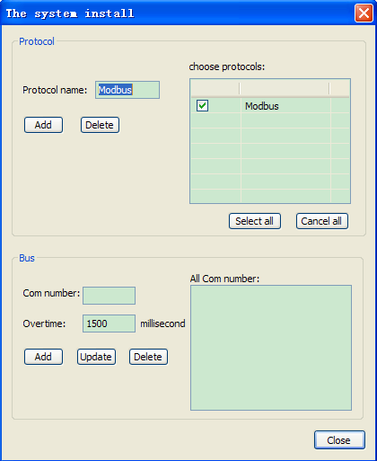

Set parameters as the following interface and click Add button. Overtime means after software sending a request command. Communication module should give a response in 1500ms . this value can be changed

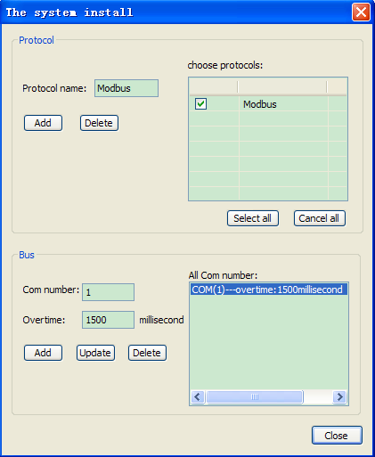

Now,the system support Com1 and Modbus.

#### 4.2.4 Bus Configuration

Click Main Menu->System->The bus install and the interface of bus configuration will show.

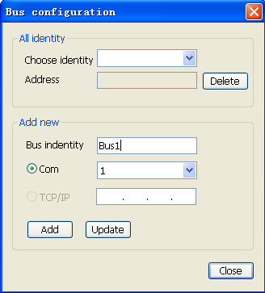

Select the COM number in "COM". COM1 is used in this example. Then input "Bus1" in "Bus Identity" , that is decided by yourself and click Add as the following figure. Click "Close" to finish adding the bus.

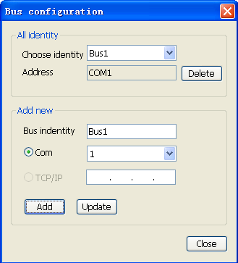

#### 4.2.5 Automatic Examination

● Configuration of automatic examination: Click Main Menu->System->The equipments examines automatically.

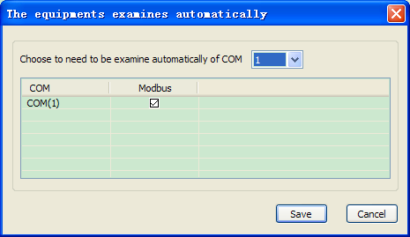

In this example, COM(1) and Modbus are selected as the above figure and then click Save.

● Automatic examination: click Main Menu->Control->Automatic Examination and the system will start automatic examination function.

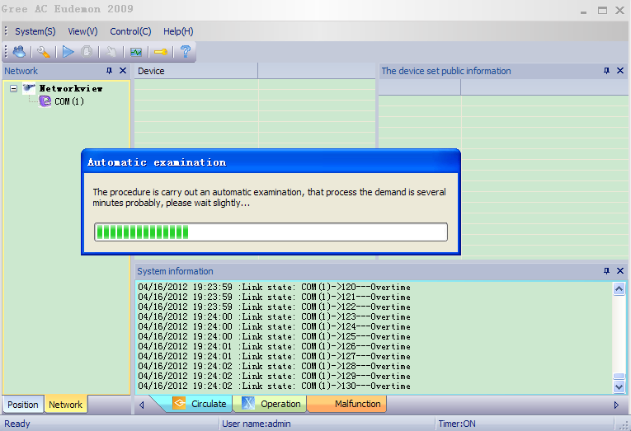

● The result of Automatic examination in the example is as below (pay attention to the networkview on the left):

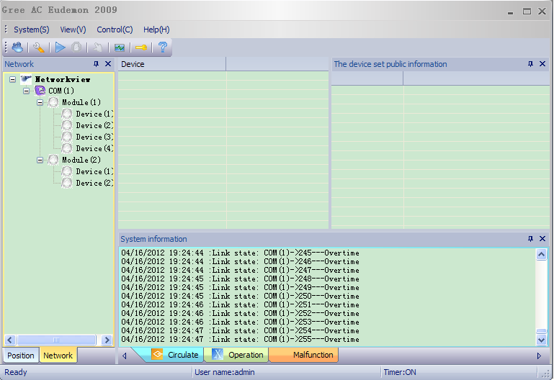

So far, the equipment is added successfully.

1. Note: Unit installation sketch is as following, please make sure the installation is complete and the communication is normal before running inspection Automatic examination.

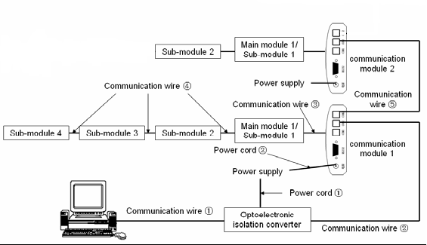

#### 4.2.6 Equipment Management

Rename the equipment: left click Equipment to select "Rename".

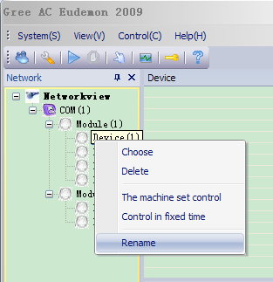

Fill in the name "Closed Control Air Conditioner ".(the name is decied by yourself)

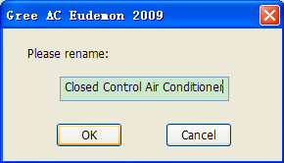

The result is as below:

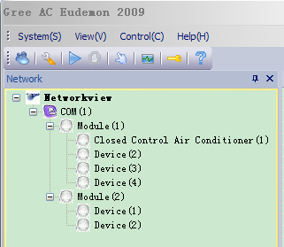

#### 4.2.7 Connect Equipments

● Link management: Click Main Menu->System->Connect management (COM1 is applied in this example) and then click "OK".

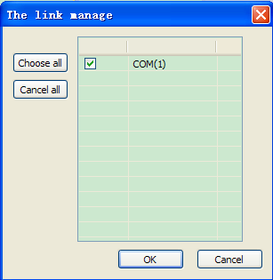

● Start Communicating: Click Main Menu->Control->Link an equipments and the system can communicate with the unit. In this case, you can check the data of units.

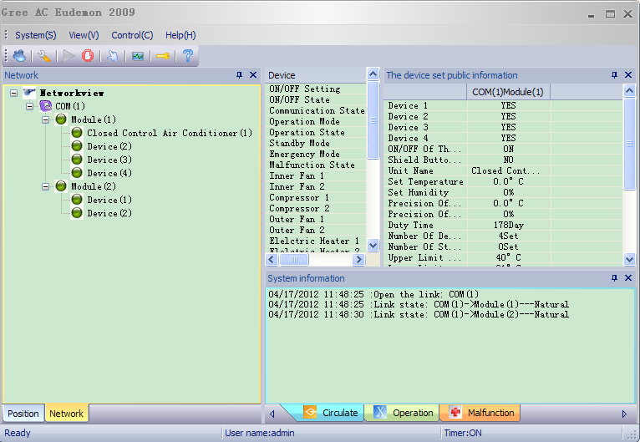

#### 4.2.8 Control Unit

● Left click any Device in Module(1), select "The machine set control" in popup menu after right click，as following picture shows:

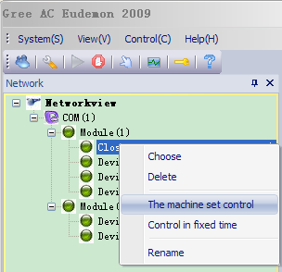

After setting the parameter in control interface, click "OK" to start operation as the figure below. No.1、No.2、No.3、No.4 in following red frame refer to Device(1)、Device(2), Device(3)、Device(4) in Module(1), when the check box before “No” is selected, the setting information in related blue frame will be sent to the unit after pressing “OK”, otherwise the settings in blue frame is invalid.

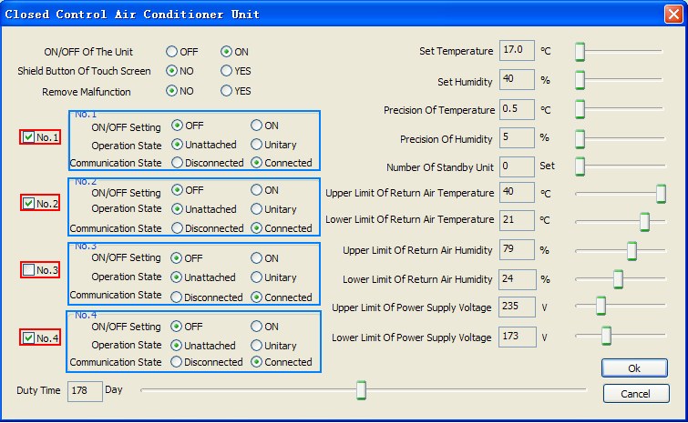

Check whether the modification is success or not by returning to the main interface.

● Left click any Device in Module(2), select "The machine set control" in popup menu after right click, as following picture shows:

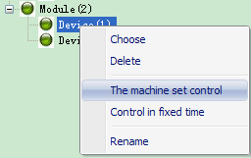

Popup control interface is as following, notice the red frame part, since there’s no Device (3) and Device(4) in Module(2), the related control part is not available for setting. Other operations are the same as 2.8.1.

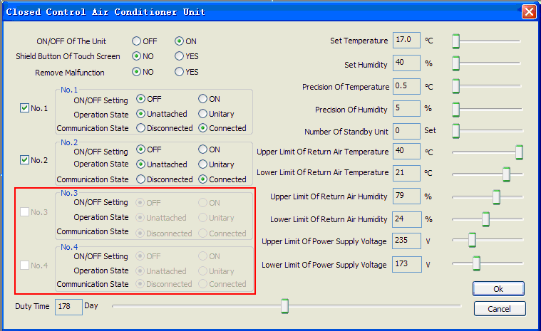

### 4.3 Display interface

Main interface consists of “menu”, “tool”, “network view”, “parameter view”, “system information view” and “status”.

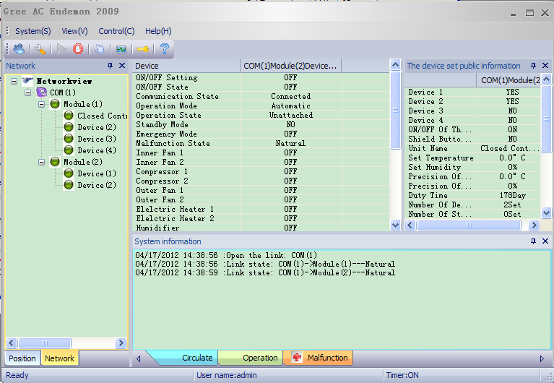

Menu: consist of “system”, “view”, “control” and “help” these four commands, there’s drop-down menu for every command to realize setting, operation, management and help viewing. The screenshot of every drop-down menu is as following:

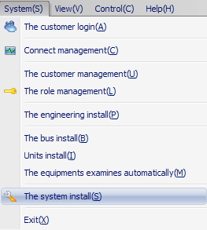

“system”

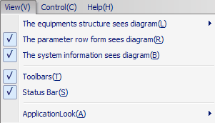

“

view”

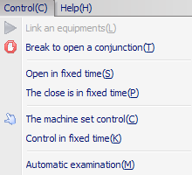

“control”

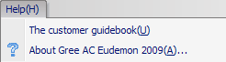

“help”

**Tool:** The buttons on “tool bar” are those setting and operation usually used in main menu. From the left to right are: the customer login, system configuration, connect, disconnect, unit control, connection management, about.

**Network view:** clearly show the project structure in “network” and “position” two ways. Select “network” to show the project topology structure; select “position” to show actual position of the project (e.g., floors and rooms where the unit is located).

**Parameter view:** consist of unit information and equipment information. Unit information shows the information of main module during modular operation, equipment information shows related parameter of selected equipment.

**System information:** consist of “Circulate”, “Operation” and “Malfunction”, separately shows the history record of running, operation and malfunction.

### 4.4 Unit and equipment management

#### 4.4.1 Add unit and equipment

Click Main Menu->System->The equipments examines automatically, the software can find the added equipment.

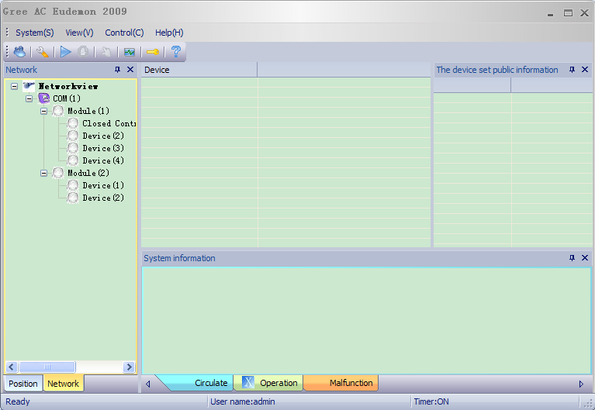

After self-checking is completed, the result will be showed on “network” of “network view”. If the result is conflict with present equipment, following dialog box will be popup and user has to select one of the result (it is advised to select the last self-checking result).

Note: main module could be connected with maximumly four submodules. During self-checking, no matter if there’s submodule, once the system is connected, it could be inspected and showed in network view. If no submodule exists, it will show communication malfunction.

Click Main Menu->System->Connect management, (COM1 is applied in this example) and then click "OK".

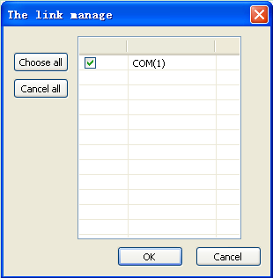

Click Main Menu->Control->Link an equipments ，the system will start checking according to saved connection. Related parameter will be displayed if the communication is normal.

Click Main Menu->Control->Break to open a conjunction, the system will stop monitoring to all the equipments.

#### 4.4.2 Project information

Before monitoring, users have to select a project. Click Main Menu->System->The engineering install and the following interface will show. Fill in the project information, click “update” and “OK” to confirm.

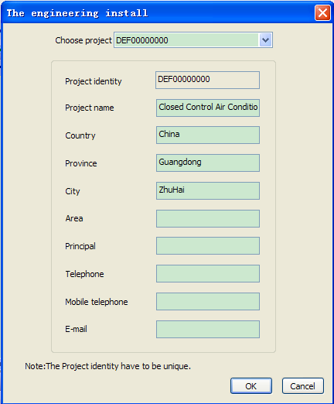

#### 4.4.3 Installation information configuration

Unit name: normally refer to the places where the AC installed, like “living room”, “bedroom”, it is named by user.

After the equipment is added, user can specify the building, floor and room according to actual installation position for convenient monitoring. The unit information can be review at “position” of “network view” in main interface. Click Menu->System->Units install Configuration and the following interface will appear.

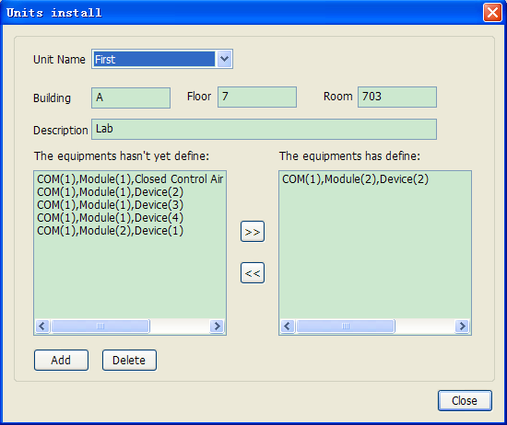

Add unit: after the information of building, floor, room and description is filled in, select the equipment need added in “the equipment haven’t yet define” frame and click, following dialog box will be popup. Fill in unit name and click “OK”, that equipment will be displayed in “The equipments have defined”, click “add” to finish the operation.

Delete unit: select the unit need delete in the drop-down list and click “delete”.

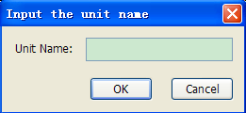

Note: same unit name cannot be added for different equipments.

#### 4.4.4 Unit and equipment names

”Software’s default name: “module (address number)” for unit/main module, “equipment (address number)” for submodule.

Right click equipment and select “rename” to input name in popup dialog box, click “OK” to confirm. Same to rename the network view, equipment information and malfunction record.

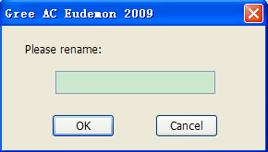

Note: address number could not be modified or deleted by renaming.

### 4.5 Parameter control

#### 4.5.1 Parameter setting

The unit could be controlled by this system, click Main Menu->Control->The machine set control (or use context menu in network view, or click  in tool), the system will popup the control interface of present selected equipment, as following picture. Well set every parameter and click “OK” to control.

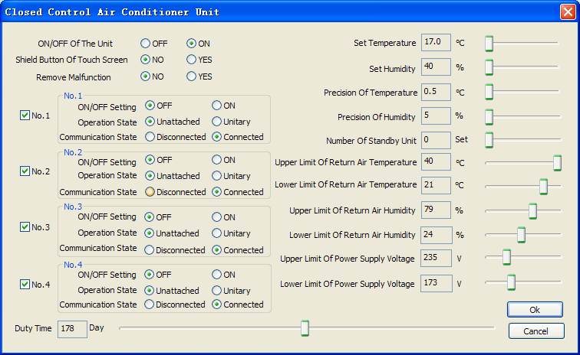

Control the main parameter of unit (main module) and equipment (submodule) through this interface.

Touch screen”: once select “shield” and send command, the touch screen of main module could be shielded and “touch screen shielded” will be displayed on homepage of touch screen, then the parameter could not be set through touch screen. Select “not to shield screen” and send command to delete the shielding of screen.

“Clear malfunction”: when unrecoverable malfunction occurs, the malfunction could be cleared and the unit could be reset by sending this command.

When there’s no equipment (submodule) in network view, the related setting button will be ashing.

When select “disconnect” for communication status, related status button like ON/OFF setting will be ashing. After the command is sent, the parameter of equipment (submodule) will still exist in “network view” but not in “equipment parameter view”.

#### 4.5.2 Timer control

Click Main Menu->Control-> Control in fixed time（or use context menu in network view），following dialog box will be popped up.

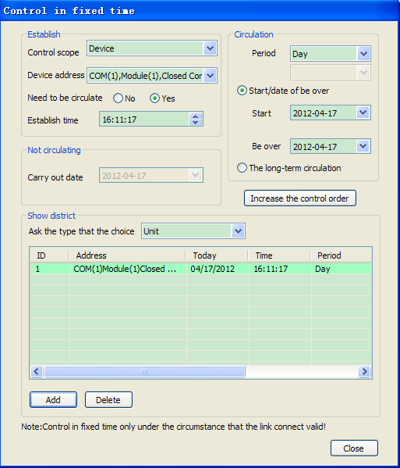

Timer adding: set related timer parameter, add control command and click “add” to confirm.

Timer deleting: select timer command in “view section” and click “delete” to confirm.

All timer controls could be showed at “view section”, if one of the timer command is overtime, it will marked with green. Check according to date or equipment is optional for users.

Note: To successfully set timer control, make sure the system is communicating with the equipment and timer switch is ON when setting. The status of timer switch could be checked in status bar, see following picture:



Timer on: click main menu -> control -> timer on; Timer off: click main menu -> control -> Timer off.

### 4.6 Running parameter view

#### 4.6.1 Unit and equipment running parameter

Click main module (unit) in network view during running communicating status of software, related parameter of main module and its submodule will be displayed, see following picture:

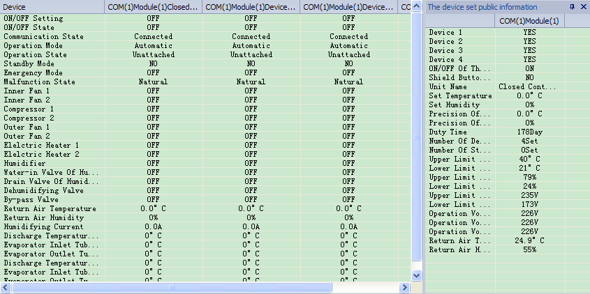

Click submodule, only the parameter of that submodule (equipment) and its main module (unit) will be displayed in equipment parameter view:

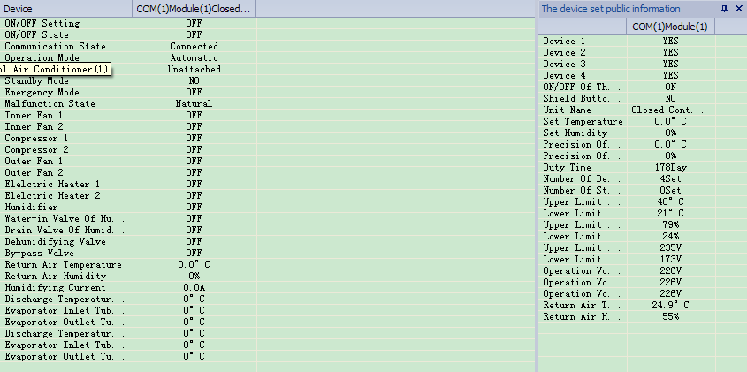

When communication of submodule is disconnected but still displayed in “network view”, its parameter will be no longer displayed in “equipment parameter view”.

When communication of main module (unit) is disconnected, the data in interface will no longer be updated and “overtime” will be reminding in running record of system information view.

#### 4.6.2 Malfunction display

During running and communication of monitoring software, if malfunction of the unit or submodule (equipment) is detected, the related malfunction information will be displayed in “malfunction record” of “system information”.

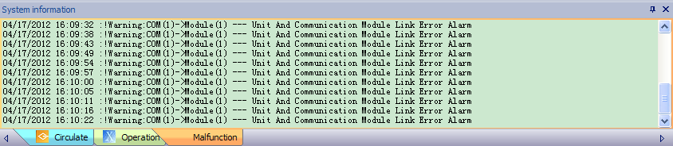

Please see appendix for detailed malfunction list.

### 4.7 User and role management

User: one user might occupy several roles.

Role: combination of some permissions

#### 4.7.1 User management

The customer management can add, modify and delete user. Click Main Menu->System->The customer management and the following interface will show.

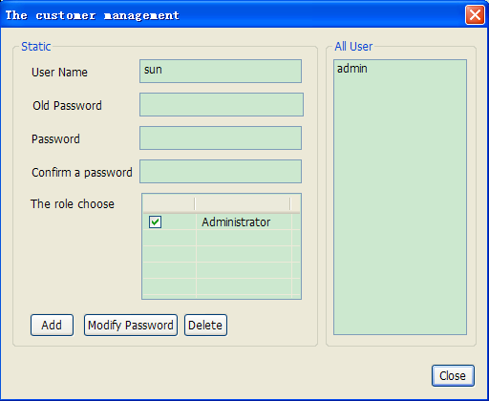

Add user: fill a different name with password and user, then click “add”.

Modify password: select a user in “all users”, type in the original password and new password, click “modify password”.

Delete user: Select a user in “all users” and click “delete”

#### 4.7.2 User management

Users having the rights of "The customer management" can add and delete role.Click Menu->System->The role management and the following interface will appear.

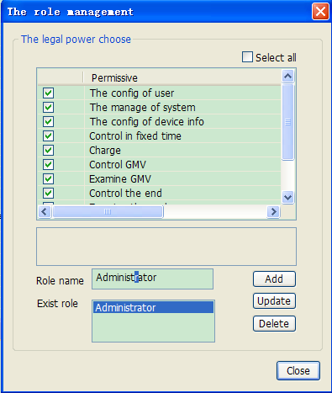

Add role: select permission in permissions list, fill in role name and click “add”.

Delete role: select a role in “role list” and click “delete”.

Note: the user is using cannot be deleted.

### 4.8 Others

#### 4.8.1 Information inquiry

Click main menu -> help -> about Gree AC Eudemon 2009，following dialog box will be popped up.

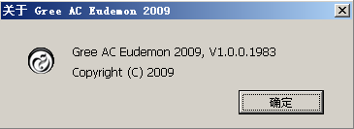

# Ⅲ Maintenance

## Malfunction List

|  |  |  |  |
| --- | --- | --- | --- |
| **Malfunction** | **Signal Source** | | **Control logic** |
| Power Error | Phase reversal protector | | When phase sequence has malfunction for continuous 3 seconds, the complete unit will stop and all loads will be turned off (without restriction of set delay time). The corresponding error code will be displayed on display and alarm will be given out. Reset or de-energize the unit to clear the error code. |
| Alarm of overheating of return air | Probe of temp and humidity of return air | | In auto mode, when indoor fan of each module has operated for over 15 min.(3 seconds for quick test), and return air temperature is higher than the upper limit for continuous 30 seconds, the corresponding malfunction code will be displayed on display and also the alarm will be given out. The unit will keep running. Reset the unit or detect that such signal has disappeared for 3 minutes (3 seconds for quick test), the malfunction code will be removed. If the unit stops for other malfunction during this course, the unit makes a judgment again. |
| Alarm of low temperature of return air | Probe of temp and humidity of return air | | In auto mode, when indoor fan of each module has operated for over 15 min.(3 seconds for quick test), and return air temperature is higher than the lower limit for continuous 30 seconds, the unit will treat the malfunction as same as the malfunction of overheating of return air. (If a module has malfunction of probe of return air, the detection of the overheating of return air will be shielded). |
| Alarm of high humidity of return air | Probe of temp and humidity of return air | | In auto mode, when indoor fan of each module has operated for over 15 min. (3 seconds for quick test), and return air humidity is higher than the upper limit for continuous 30 seconds, the unit will treat the malfunction as same as the malfunction of overheating of return air. (If a module has malfunction of probe of return air, the detection of the overheating of return air will be shielded). |
| Alarm of low humidity of return air | Probe of temp and humidity of return air | | In auto mode, when indoor fan of each module has operated for over 15 min.(3 seconds for quick test), and return air humidity is higher than the lower limit for continuous 30 seconds, the unit will treat the malfunction as same as the malfunction of overheating of return air. (If a module has malfunction of probe of return air, the detection of the overheating of return air will be shielded). |
| High temperature protection for discharge of compressor | Discharge temp sensor | | When compressor operates, if compressor discharge temperature is higher than set value for continuous 30 seconds, compressor and corresponding loads (valve for dehumidifying and gas by-pass valve) will be turned off without being restricted by set delay time. The outdoor fan will be turned off 5 seconds later, the corresponding malfunction will be displayed on display and alarm also will be given out. After 3 minutes, if discharge temp is lower than 90 ℃, the malfunction will be removed and the system will resume operation without being restricted by set delay time. If discharge temp ≥90℃, or the protection occurs 3 times during 1 hour, there is such malfunction and the system can’t automatically resume operation. The corresponding malfunction will be displayed and alarm will be given out. Reset or de-energize the unit to clear the malfunction signal. |
| Low pressure protection of compressor | Pressure controller | | When compressor operates for over 15 seconds and the low pressure signal is detected during set delay time, compressor and corresponding loads will be turned off without being restricted by set delay time. The outdoor fan will be turned off 5 seconds later, the corresponding malfunction will be displayed on display and alarm also will be given out. After 3 minutes, if low pressure controller is automatically reset, the compressor will automatically operate without being restricted by delay time and the malfunction will be removed. If the malfunction can’t be removed automatically, or the protection occurs 3 times during 1 hour, there is such malfunction and the operation can’t be automatically resumed. The corresponding malfunction code will be displayed and alarm will be given out. Reset or de-energize the unit to clear the malfunction signal. |
| Low pressure protection of compressor | Pressure controller | | When high pressure signal is detected for continuous 3 seconds, compressor and corresponding loads will be turned off without being restricted by set delay time. The outdoor fan will be turned off 5 seconds later, the corresponding malfunction will be displayed on display and alarm also will be given out. The malfunction can’t be automatically removed. Reset or de-energize the unit to clear the malfunction signal. |
| Overload protection of compressor | Overcurrent protector | | When overload of compressor is detected for continuous 3s, compressor and corresponding loads will be turned off without being restricted by set delay time. The outdoor fan will be turned off 5 seconds later, the corresponding malfunction will be displayed on display and alarm also will be given out. After 3 minutes, if overload of compressor is automatically removed, the compressor will automatically operate without being restricted by delay time and the malfunction signal will be removed. If the malfunction can’t be removed automatically, or the protection occurs 3 times during 1 hour, there is such malfunction and the operation can’t be automatically resumed. The corresponding malfunction will be displayed and alarm will be given out. Reset or de-energize the unit to clear the malfunction signal. |
| Overload protection of indoor fan | built-in guard wire of indoor fan | | If overload of indoor fan is detected for continuous 3 seconds, the complete unit will stop and all loads will be turned off without being restricted by delay time. Corresponding malfunction will be displayed and alarm will be given out. Reset or de-energize the unit to clear the malfunction signal. |
| Overheating protection of electric heater | Thermostat | | When thermostat is off for continuous 3s, corresponding electric heater will be turned off and it can’t automatically resume operation. Corresponding malfunction will be displayed and alarm will be given out. Reset or de-energize the unit to clear the malfunction signal. |
| Low air pressure malfunction of indoor fan | Air pressure switch | | When indoor fan operate for 10s, if the signal of activation of air switch is detected for continuous 3s, the complete unit will stop and all loads will be turned off without being restricted by set delay time. |
| Alarm of blocking filter | Air pressure switch | | When indoor fan operate for 10s, if the signal of activation of air switch is detected for continuous 3s, the corresponding malfunction will be displayed and alarm will be given out without affecting other loads. When indoor fan operates, if air switch of filter works normally for continuous 1 min, the malfunction will be removed. Reset or de-energize the unit to clear the malfunction signal. |
| Malfunction of probe for return air | Probe of temp and humidity of return air | If detect that the probe for return air failures for continuous 1 min, indoor fan will operate when the unit is started up while it will be turned off when the unit is turned off. The compressor and corresponding load, electric heater and humidifier will be turned off according to manual turning off sequence. The outdoor fan will be turned off in 5s. The corresponding malfunction will be displayed and alarm will be given out. If the probe for return air is automatically resume normal work, the compressor, electric heater and humidifier will resume operation and malfunction signal will be removed. If the malfunction is not removed, pressing reset button will not work. Manually turn off and de-energize the unit to clear the malfunction signal. | |
| Low current malfunction of humidifier | Current transformer | When humidifier operates (HUMID closes), if current for humidifying is lower than 1 A for continuous 10 min (feed valve may not turned on/discharge valve may not turned off/ short circuit may occurs between electrodes/ purified water may be used), switch off the humidifier without affecting other loads. Corresponding malfunction will be displayed, and alarm will be given out. Manually turn off and de-energize the unit to clear the malfunction signal. | |
| Drainage malfunction of humidifier | Current transformer | When humidifier operates (HUMID closes), if current for humidifying is lower than 1.3Iset for continuous 3 min, switch off the humidifier without affecting other loads. Corresponding malfunction will be displayed, and alarm will be given out. Manually turn off and de-energize the unit to clear the malfunction signal. | |
| High water level protection of humidifier | High water level switch of humidifier | When humidifier operates (HUMID closes), if the signal of high water level is detected for continuous 20 min, switch off the humidifier without affecting other loads. Corresponding malfunction will be displayed, and alarm will be given out. Manually turn off and de-energize the unit to clear the malfunction signal. | |
| Alarm for water on floor | Flooding switch | When signal from flooding switch is detected for continuous 30s (3s for quick test), the complete unit will stop and all loads will be turned off without being restricted by set delay time. Corresponding malfunction will be displayed, and alarm will be given out. Manually turn off and de-energize the unit to clear the malfunction signal. | |
| Sub-module communication malfunction | Mainboard | If there is communication malfunction between sub-module and main module for 30s, the indoor fan will operate once the unit is started up while it will be turned off once the unit is turned off. Compressor, electric heater and humidifier will be turned off according to manual turning off sequence. Corresponding malfunction will be displayed, and alarm will be given out. Manually turn off and de-energize the unit to clear the malfunction signal. | |
| Main module communication malfunction | Mainbaord | If there is communication malfunction between sub-module and main module for 30s, the indoor fan will operate once the unit is started up while it will be turned off once the unit is turned off. Compressor, electric heater and humidifier will be turned off according to manual turning off sequence. Corresponding malfunction will be displayed, and alarm will be given out. If mainboard resume communication to touchable screen automatically, the unit will resume operation and malfunction signal will be removed. Manually turn off and de-energize the unit to clear the malfunction signal. | |
| Communication malfunction of remote monitoring | Main board | If there is communication malfunction between main module and remote monitoring module, “remote monitoring” will disappear on homepage of screen and corresponding malfunction will be displayed on malfunction area of remote monitoring interface, along with “Buzz”. The unit will keep operation. When communication is resumed, the malfunction will be automatically removed. | |
| Customer linkage protection | Main board | If linkage signal is detected for continuous 30s (3s for quick test), the complete unit will be turned off without being restricted by set delay time. Manually turn off and de-energize the unit to clear the malfunction signal. | |
| Fire alarm | Main board | If signal of fire alarm is detected for continuous 3s, the complete unit will stop without being restricted by set delay time. Corresponding malfunction will be displayed, and alarm will be given out. Reset or de-energize the unit to clear the malfunction signal. | |
| Adhesion alarm of electric heating | AC contactor of electric heater | When electric heater is turned off and adhesion of AC contactor is detected for continuous 10s, if indoor fan is turned off, it will be turned on while if it operates, it will keep operating. Other load will normally work. Corresponding malfunction will be displayed, and alarm will be given out. It can’t be automatically resume normal operation and pressing reset button will not work. De-energize the unit to clear the malfunction signal. | |
| Discharge temp sensor/ inlet pipe of evaporator temp sensor/outlet pipe of evaporator temp sensor malfunction | Temp sensor | If the temp sensor is short of open circuit for continuous 30s, compressor and corresponding loads will be turned off without being restricted by set delay time. Outdoor fan will be turned off in 5 seconds. Corresponding malfunction will be displayed, and alarm will be given out. If the malfunction is automatically removed, the compressor resumes operation and malfunction code will be removed. Select malfunction resetting or manually de-energize the unit to clear the malfunction signal. ( Application range of discharge temp sensor: 20℃～149℃; Application range of other temp sensors: -40℃～127℃; Malfunction will be displayed when it goes beyond the range. | |

## 2. Troubleshooting

### 2.1 High Pressure Protection of Compressor

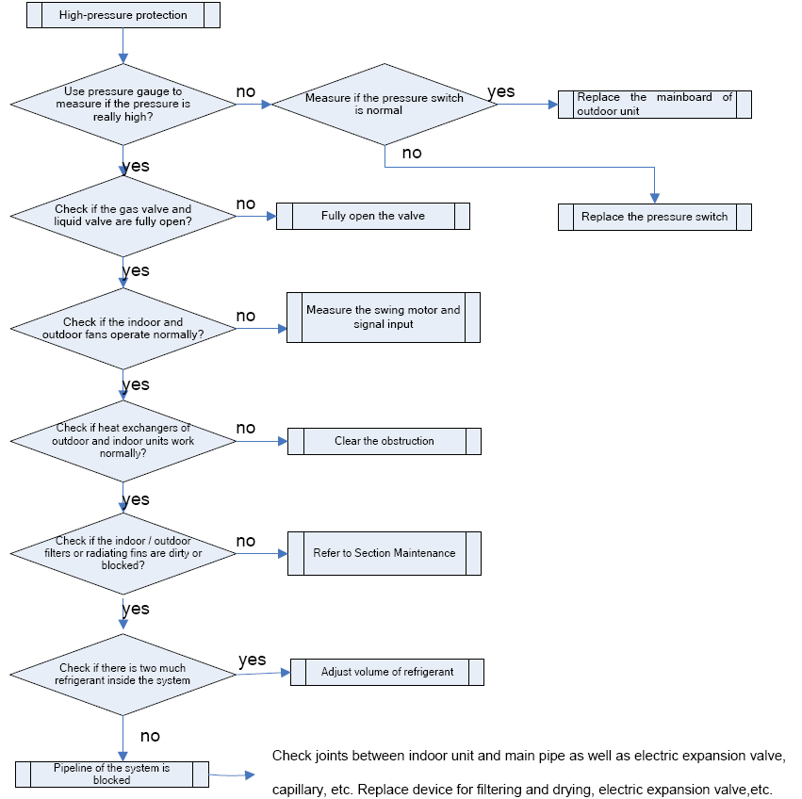

### 2.2 Low Pressure Protection of Compressor

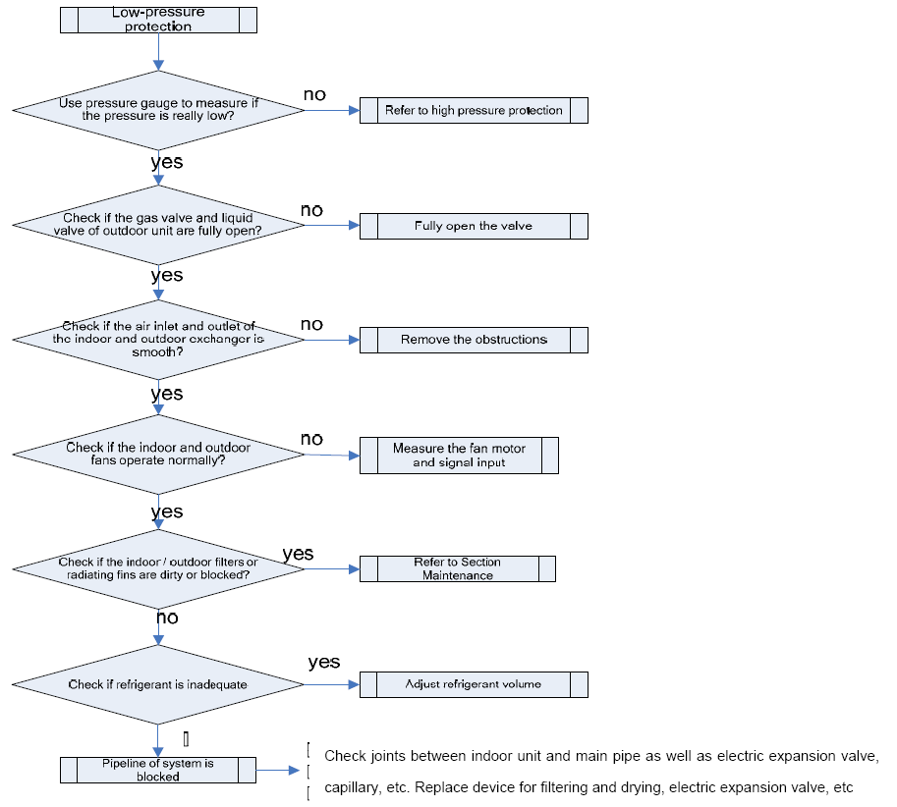

### 2.3 Discharge Temp Protection for Compressor

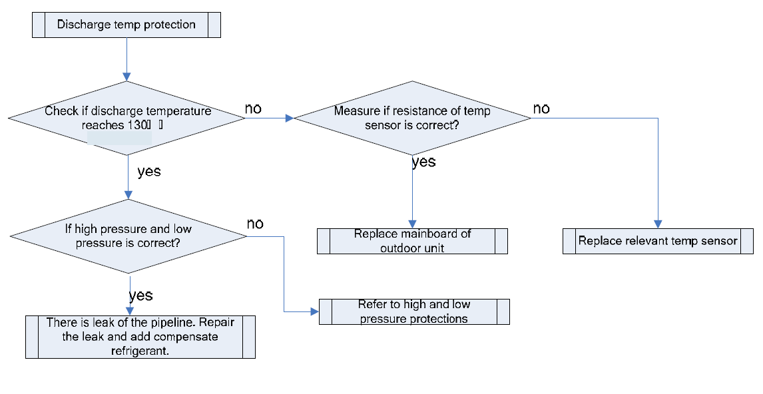

### 2.4 Overload Protection of Compressor

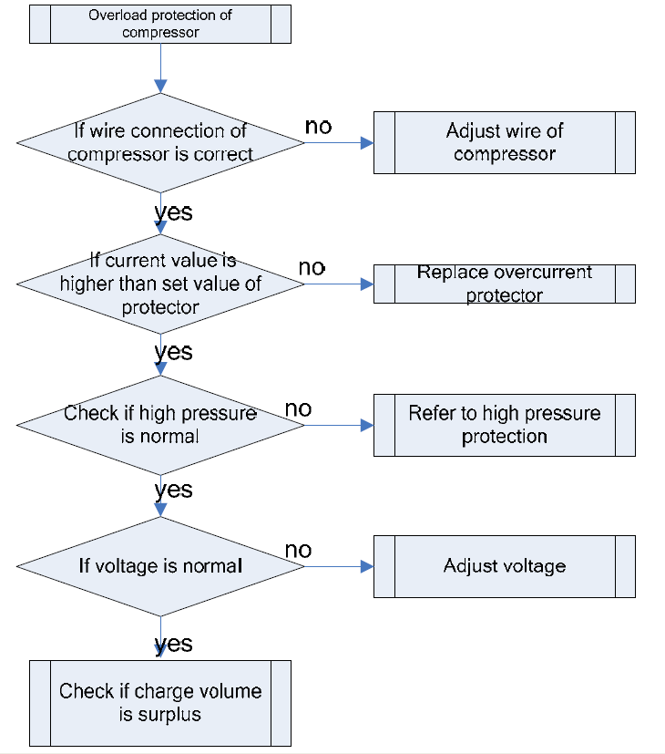

### 2.5 Overload Protection of Indoor Fan

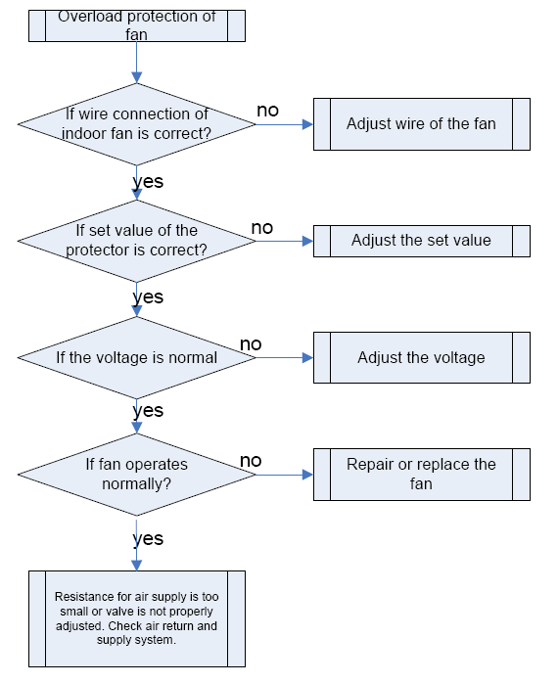

### 2.6 Temperature Protection of Electric Heater

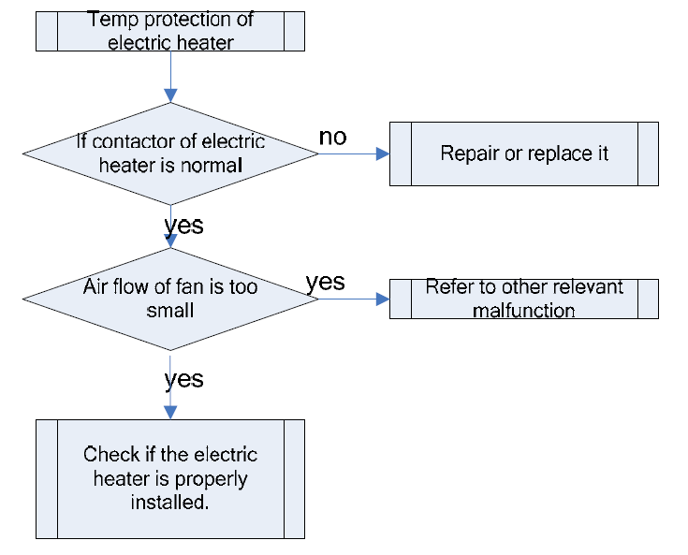

### 2.7 Low Current Malfunction, Drainage Malfunction and High Water Level Malfunction of Humidifier

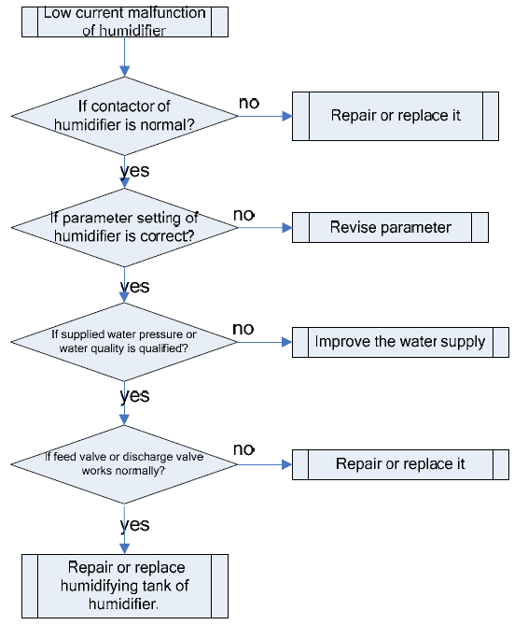

### 2.8 Low Air Pressure Malfunction of Indoor Fan

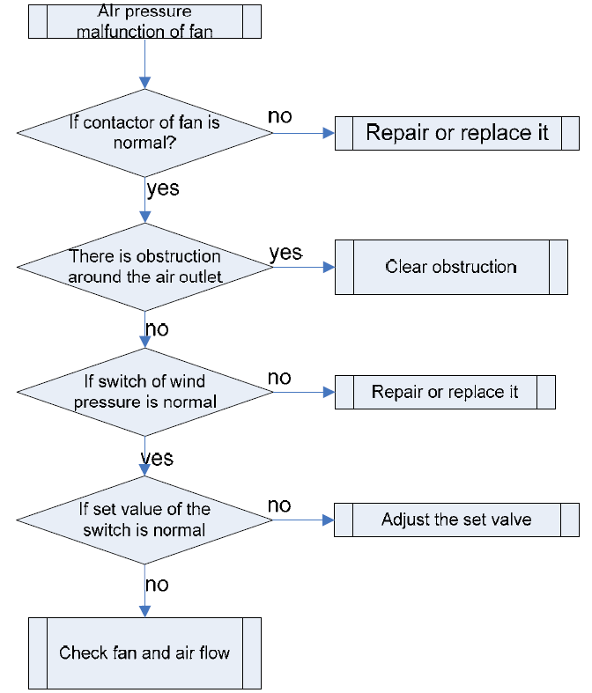

### 2.9 Alarm for Blocking Filter

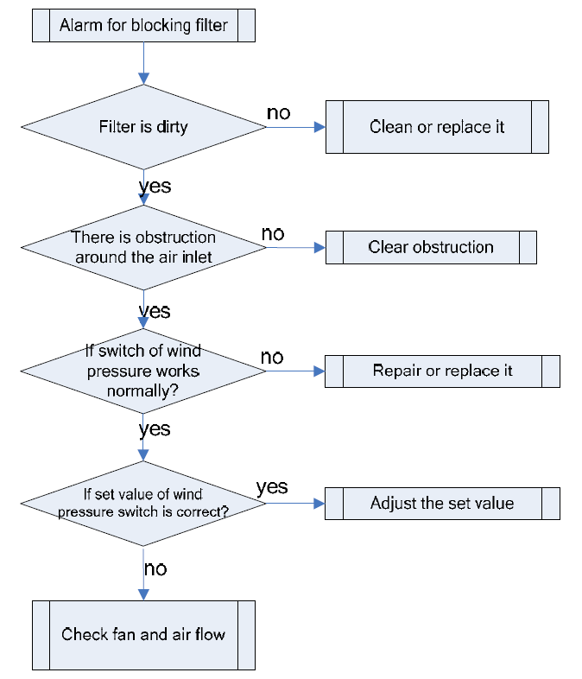

## 3. Case Study

#### Case 1

**Malfunction Phenomenon**: Low pressure protection occurs after the unit operates normally in cooling mode for a period of time.

**Possible causes:** pressure controller is abnormal; parameter setting of touch screen is abnormal; air return and supply are not smooth; pipeline is blocked (including expansion valve, filter, etc.).

**Analysis of root cause:** Firstly, check each set parameter and the set parameters are factory setting so there is no problem. Check if air flow around the air inlet and outlet is smooth and check if there is any obstruction. After inspection, it is found that there is no obstruction around the air inlet and outlet and air flow and air volume are normal. Check if wiring of pressure controller is normal. Check low pressure of the unit and the low pressure is 0.05MPa which is within the low pressure protection range. So there is no malfunction of pressure controller. Check the status of pipeline. Observe the pipe by viewing mirror and it is found that there is almost no liquid flowing through the mirror. The pipeline in front of the mirror may be blocked. After inspection of pipeline, it is found that the temperature difference between the front part and the rear part of the filter is huge but other pipes are normal. So we can get a conclusion that the filter is blocked. After replacing the filter, the unit resumes normal operation.

**Conclusion:** There are obstacles in the cooling system, which causes blockage of filter when the system is running.

#### Case 2

**Malfunction Phenomenon:** high water level protection of humidifier during debugging of the unit.

**Possible causes:**

（1）High water level protector has malfunction;

（2）Water discharge valve can’t be started up;

（3）Water inlet valve can’t be turned off;

（4）Current transformer is damaged;

（5）Water quality is bad.

**Analysis of root cause:** Firstly, check if water level of humidifier tank is normal. Actually, the tank is full of water and there is high water level. Therefore, high water level protector doesn’t have malfunction. Switch the unit to manual debugging mode by touchable screen. Manually turn off/on the valve of humidifier and it is works normally. So there is no relevant malfunction. Then manually drain the water inside the tank of humidifier and then manually turn on the humidifier. Measure current for humidifying and compare it with that in touchable screen. At the same time, observe water level of humidifier tank and status of valve on screen. In fact, the current measured is almost the same with that displayed on screen. So there is no malfunction of current transformer. With increase of water level inside the humidifier tank, the current value increases. When water valve is in off status on screen, current value is 3.7. When water level keeps increasing, the current value increases too. In that case, there is high water level alarm and the current value is 4.3. So we can get a conclusion that high water level alarm is caused due to small humidifying current as the humidifier tank is full of water which is incurred by small electric conductivity of water supplied.

**Conclusion:** When humidifying current is two low due to bad electric conductivity of water supplied or long operation of the humidifier, treat the water to improve its electric conductivity(eg, adding dissolving salt) so that the humidifier can normally operate.

#### Case 3

**Malfunction Phenomenon:**

In normal conditions, touchable screen shows warning “water on floor” and the unit can’t be started up.

**Possible causes:**

（1）Flooding switch is damaged;

（2）Electrode is damaged;

（3）Wiring is incorrect.

**Possible causes:** check if the power indicator of flooding switch is on. If not, it means there is no +12V power supplied for flooding switch. Check if the wiring of mainboard is correct. If it is correct, replace the flooding switch. When power indicator of flooding switch is on, check if malfunction indicator is on. If it is on, there is a malfunction. Open shell of flooding switch to check if electrode is short-circuited or the wiring terminal is oxidized. When malfunction is removed, the malfunction indicator will be off. Press reset button to clear the warning. If power indicator of flooding switch is on and malfunction indicator is off, the switch is ok. Check if wire connecting to mainboard is correct. If it is correct, replace the mainboard.

**Conclusion:** when touchable screen shows warning “water on floor”, the unit will stop and can’t be started up, which may be incurred by oxidization of electrode, short circuit, malfunction of flooding switch or loose wiring of mainboard.

#### Case 4

**Malfunction Phenomenon:** the mainboard of controller doesn’t work after energization and the communication indicator doesn’t blink. Touch ON button on touchable screen, the outdoor unit doesn’t operate.

**Possible Causes:**

（1）Mainboard is burnt out;

（2）Protective tube is damaged;

（3）Wrong wiring

**Possible causes:** remove electric box to check the mainboard. If it is burnt out, the mainboard shall be replaced.

Check if protective tube breaks. If so, the protective tube shall be replaced. Check if null wire or live wire of power cord is short-circuited. If so, remove the malfunction and re-energize the unit.

Check if the wiring is correct according to wiring diagram. Check the conductivity of wire by universal meter.

Once the unit is energized, check if power indicators D3, D30 are bright. If they are bright, mainboard +5V is correct. Buzzer of mainboard will sound after energization. If it is not sound, the mainboard has malfunction and needs to be replaced. Check +5V、+12V、-12V by universal meter. If they are normal, transformer and rectifier circuit are normal, or else they need to be replaced. Check communication indicator D4 of mainboard. If D4 is blinking, the communication between mainboard 2 and mainboard 1 is normal. If communication indicator D12 blinks, communication between mainboard 2 and touchable screen is normal. If it is abnormal, check if the communication wire is connected correctly.

**Conclusion:** if null wire and live wire are short circuited, protective tube will break or mainboard will be burnt out. If wiring is loose or breaks, communication of mainboard will be abnormal and the unit will not operate.

## 4. Power Distribution of the Unit

### 4.1 Power Distribution Diagram

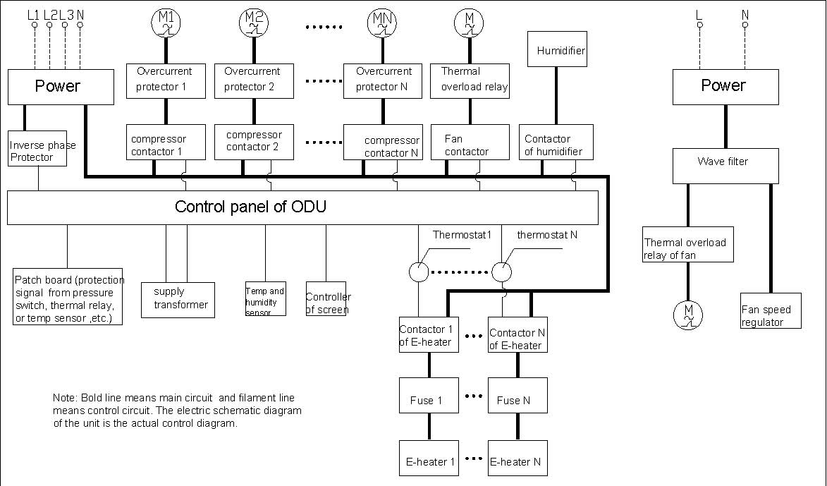

#### 4.1.1 Phase Reversal Protector

（1）Protection conditions: Input terminal of power supply for the protector is phase reversal;

（2）Result of activation: The complete unit is de-energized and can’t be turned on;

（3）Treatment: Adjust wire sequence of power patch board. Check if the voltage of three-phase power is normal.

#### 4.1.2 Thermal Overload Relay:

（1）Protection conditions: Current of motor is huge and currents of three phases are not in balance. There is phase loss.

（2）Result of activation: Overload protection of motor will be shown on wired controller;

（3）Treatment: Check if winding of three phases of compressor is normal. If it's normal, turn on the unit again and check if the working current of motor is normal.

#### 4.1.3 Thermostat:

（1）Protection conditions:Temperature of controlled parts reaches the set value;

（2）Result of activation: Contact of thermostat is on or off;

（3）Treatment: During normal operation, when the temperature of a controlled part reaches the preset value, the temp sensor whose activation temperature is fixed or adjustable will cut on or off the circuit. It can be automatically or manually reset.

#### 4.1.4 Overcureent Protector of Compressor:

（1）Protection conditions: Current of motor is huge and currents of three phases are not in balance. There is phase loss.

（2）Result of activation: Overload protection of motor will be shown on wired controller;

（3）Treatment:：Check if winding of three phases of compressor is normal. If it is, turn on the unit again and check if the working current of compressor and system pressure are normal.

#### 4.1.5 Fusible Cutout:

（1）Protection conditions: Temperature of controlled parts reaches the set value;

（2）Result of activation:：Contact of fusible cutout is on or off;

（3）Treatment:： During normal operation, when the temperature of a controlled part reaches the preset value, the temp sensor whose activation temperature is fixed or adjustable will cut on or off the circuit. It can be automatically or manually reset.

#### 4.1.6 AC contactor:

（1）activation conditions: Coil of AC contactor is energized;

（2）Result of activation: Main contact closes and load is started up.

### 4.2 Circuit Diagram (The circuit diagram is for reference only and the circuit diagram on the unit is the standard.)

#### 4.2.1 Indoor Unit JKFD5DXXX(I)、JKFD7DXXX(I)

#### 

#### 4.2.2 Indoor Unit JKFD7XXX(I)

#### 4.2.3 Indoor Unit JKFD13XXX(I)、JKFD19XXX(I)

#### 4.2.4 Indoor Unit JKFD25C2/Na-M(I)、JKFD25QS2/Na-M(I)

#### 4.2.5 Indoor Unit JKFD25SX2/Na-M(I)

#### 4.2.6 Indoor Unit JKFD40XXX(I)

